**Article:** Churn analysis using deep convolutional neural networks and autoencoders

**Link:** https://arxiv.org/ftp/arxiv/papers/1604/1604.05377.pdf

**Dataset**: 6 million customers labeled data (12 features for each customer)

**Algorithm:**

supervised learning CNN: using customer temporal behavior to perform churn prediction (image classification)

unsupervised learning autoencoder: to understand the reason for customer churn

AUC : .743

**types of data needed for customer churn:**

represent customers as images: 2 dimensional array of normalized pixels where each row is for each day and each column is for each type of behavior tracked 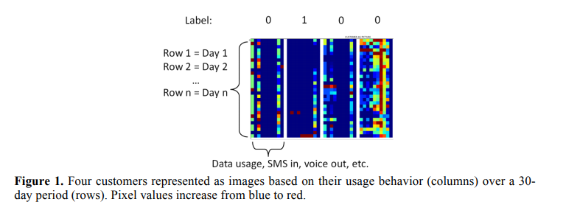

Timeline activities of customer:

Timeline of their activity on the service

Example: within the past 30 days, what were their “behavior” on the site

Types of behavior: subscription frequency, subscription type (plan, services), type of customer (student, business, learner), active/ non active on which day, how much data are they using/storing/downloading

Things that needs to be defined: last call window, predictor window, churn assessment window, customer’s life time-line, minimum age on subscription